Legends of Sword and Wand
Requirements Documentation

Table of Contents
- Introduction
- Major Design Decisions
- Sequence Diagrams
- Architecture
- Class Diagrams and Initial Implementation
- Design Patterns
- Activities Plan, Product Backlog, and Sprint Backlog
- Group Meeting Logs
- Test Driven Development (TDD)

GitHub Repository Link: https://github.com/Kevin-Bui1/CloudComputing-Legend-of-Sword-and-Wand.git

Version | Date | Authors | Changes
0.1 | 2026/02/20 | Kevin, Tobi | Organized document to set up for requirements design document
0.2 | 2026/02/22 | Kevin | Created project overview and microservice architecture
0.3 | 2026/02/23 | Kevin, Tobi | Added sequence diagrams and class diagrams
0.4 | 2026/02/25 | Kevin, Tobi | Added microservice interfaces and test cases.
0.5 | 2026/03/01 | Kevin, Tobi | Added CI/CD pipeline explanation, Docker deployment section, and refined architecture description.
1.0 | 2026/03/05 | Kevin, Tobi | Edited and reviewed Deliverable 1 documentation.

Introduction
This document presents the Software Design Description for Legends of Sword and Wand, outlining the system architecture, major design decisions, module decomposition, and final implementation for the completed project. Focused on establishing a modular, object-oriented architecture, this document details the integrated design patterns and system interactions that drive the application. The game itself is a dungeon-based RPG featuring secure profile creation, a dynamic turn-based battle engine, PvE campaign progression, a persistent PvP matchmaking system, and seamless database integration for storing party status, match history, and campaign progress.

Major Design Decisions

This project focuses on promoting modularity, high cohesion and low coupling by dividing the system into microservices with each service being responsible for one area of the game instead of one type of code. The profile service is in charge of anything related to user accounts, the database service handles all database related tasks and this pattern applies to the remaining services. This design allows for easy maintainability as whatever needs to be added or fixed, only the service that owns it will be worked on while the rest remain untouched. It also allows for the group member in charge of a service to test and deploy the service independently and any issues that happen in one service will not affect another.
The profile creation and login system part separates UI, logic, and data into a layered design. LoginScreen is a Java Swing view that displays the interface for users to register or login and sends them outcome messages while taking that input and sending it to AccountManager. Behind the interface, AccountManager handles the registration and authentication logic as well as using IUserDB to contact the database. This layer design ensures each class has one specific role and changes in a layer don’t affect the other layers.
The PvE module manages the player-versus-environment gameplay. It consists of the PvEController, which serves as the entry point for PvE mode, handling campaign initialization, continuation, and retrieval. The Campaign class maintains the state of the dungeon, including the current room, the associated Party, and progression tracking. Rooms are created dynamically via the RoomFactory, and all room interactions are abstracted through the Room class, with specialized behavior implemented in BattleRoom and InnRoom. The Party class encapsulates hero management, inventory, and resources, providing controlled access to the heroes and gold. This modular structure ensures that the PvE system is extensible, testable, and isolates gameplay logic from UI concerns.
The battle system takes care of the turn-based combat between a user’s party and enemies either generated or another player. Battle class contains the core logic consisting of the turn order, action, and win checking. The actions during battles are encapsulated in their own strategy class which follows the Strategy pattern allowing for future actions to be added without modifying Battle, further promoting maintainability. HeroDecorator uses decorator pattern to apply temporary stat bonuses without affecting the hero itself and BattleObserver uses the observer pattern allowing BattleGUI to listen for battle events then update the battle log so the logic and UI is not mixed.
To achieve low coupling, the database operations are separated from the rest of the system. The GameSaveDAO acts as a boundary between the app and the database by handling all SQL for users, progress, inventory, scores and PVP results. None of the other classes write SQL queries directly, instead the game logic simply passes data such as hero and party information to GameSaveDAO. This means if the database schema changes, none of the other project system parts are affected. This keeps all database implementation together, giving the persistence layer high cohesion.

Microservice Architecture
Service | Responsibility | Owner | Port
Profile | User registration and login | Kevin | 5000
Battle | Battle and combat logic | Tobi | 5001
PvE | Campaign progress and room generation | Tobi | 5002
PvP | Player vs player invitation and match results. | Kevin | 5004
Data | Database access and campaign persistence. | Kevin | 5003

This system is composed of several independent microservices that communicate through REST APIs. Each service runs as a separate Docker container, allowing them to be deployed and managed independently. This separation ensures scalability and allows the individual services to be updated without causing harm to the rest of the system.
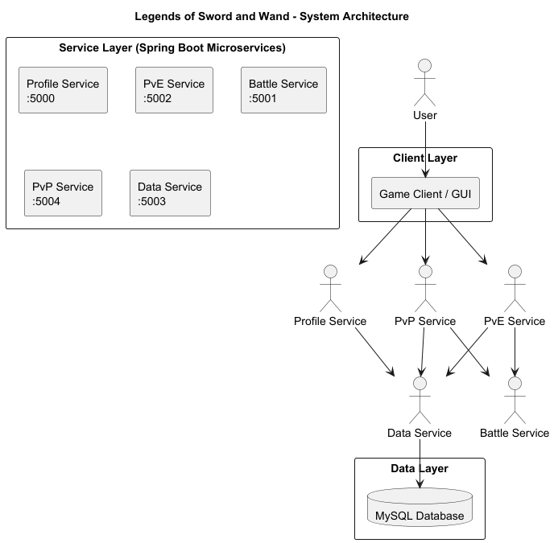

The client interface communicates with the backend through REST APIs. The profile service handles user accounts involving registration and login. PvE service takes care of user progression through campaign missions. The battle service performs the turn-based combat components and logic. The data service manages all interactions with the database.

API Gateway
This project uses an nginx-based API gateway as the single public entry point running on port 8080. The gateway sends requests to the correct backend service based on the URL path prefix. This design follows the smart endpoints and dumb pipes principle, by simplifying the client interaction through one endpoint and handling routing internally in the system.

URL Path Prefix | Route | Port
/profile/ | Profile Service | 5000
/battle/ | Battle Service | 5001
/pve/ | PvE Service | 5002
/data/ | Data Service | 5003
/pvp/ | PvP Service | 5004

Microservice Interfaces
This section describes how each microservice in this system is accessed. Each microservice provides a set of REST API endpoints that other services or applications can call, communicates using RESTful HTTP APIs and exchanges data in JSON format.

COMMON RULES
Protocol: HTTP
Data format: JSON
Request Type: application/json
Response Type: application/json

COMMON RESPONSE CODES
200 OK = request successful
201 Created = new resource created
400 Bad Request = invalid input
404 Not Found = requested data does not exist

Profile Service

Purpose: Manages User Accounts such as login, registration, and retrieving player profiles.
Register User: Creates a new player account. Method = POST
Login: Allows an existing user to log into the system. Method = POST
Get Profile: Returns information about a player’s profile. Method = GET
Health Check: Used to confirm that the service is running. Method = GET

Battle Service
Purpose: Handles battle logic such as starting battles and calculating turns
Start Battle: Starts a new battle between 2 groups. Method = POST
Perform Turn: Processes a single turn in a battle. Method = POST
Battle Result: Returns the final result of the battle. Method = GET
Health Check: Confirms Battle service is functioning. Method = GET

PvE Service
Purpose: Handles PvE environment logic such as starting campaigns and saving user campaign progress.
Start Campaign: Starts a new PvE campaign for players. Method = POST
Save Game: Saves the player’s current progress in their campaign. Method = POST
Load Game: Loads a player's saved campaign. Method = GET
Health Check: Confirms the PvE Service is functioning and running. Method = GET

Data Service
Purpose: Stores and gets game data such as user profiles, battle results, and campaign saves.
Save User Data: Stores user information in database. Method = POST
Get User Data: Gets users stored information. Method = GET
Save Campaign Data: stores PvE campaign data. Method = POST
Health Check: Confirms Data service is functioning. Method = GET

PvP Service
Purpose: Handles PvP battles, invitations, and match results.
Send PvP Invitation: Sends a battle invite to another player: Method = POST
Accept Invitation: Allows a player to accept a PvP invite. Method = POST
Report Match Result: Records the result of a PvP battle. Method = POST
Health Check: Confirms the PvP service is functioning. Method = GET

CI/CD Pipeline
This project used GitHub Actions for continuous integration and deployment.
The pipeline performs these steps:
- Build each microservice using Maven
- Run automated unit tests
- Builds Docker images for each service.
- Starts containers using Docker Compose to ensure the system runs correctly.
This pipeline ensures changes to the code that are pushed to the repository are automatically tested.

Docker Images
Each microservice in the system is packaged as a Docker container which allows the services to be deployed independently and ensures consistent environments across machines. A Dockerfile is provided for each service. Docker Compose is used to start all services together including the database.

Sequence Diagrams
USE CASE 1: Profile creation and log in
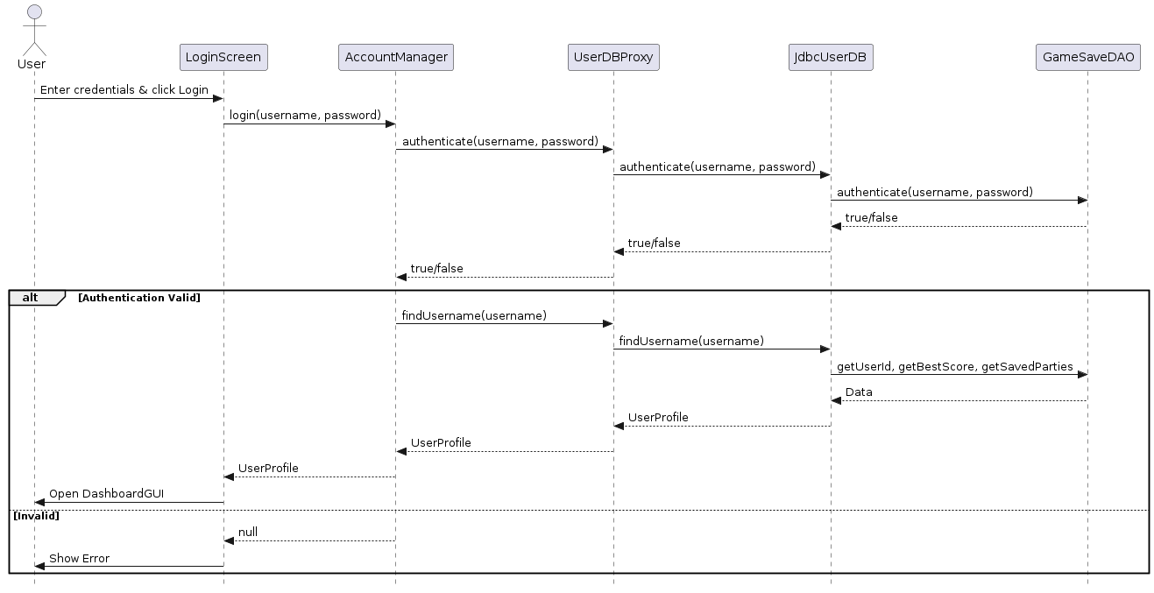
The user inputs their username and password on the LoginScreen. The request traverses the AccountManager to a UserDBProxy, which forwards it to the JdbcUserDB. The GameSaveDAO evaluates the credentials matching the hashed password in the MySQL database. On success, the user profile is assembled and the DashboardGUI opens.

USE CASE 2: Pve Campaign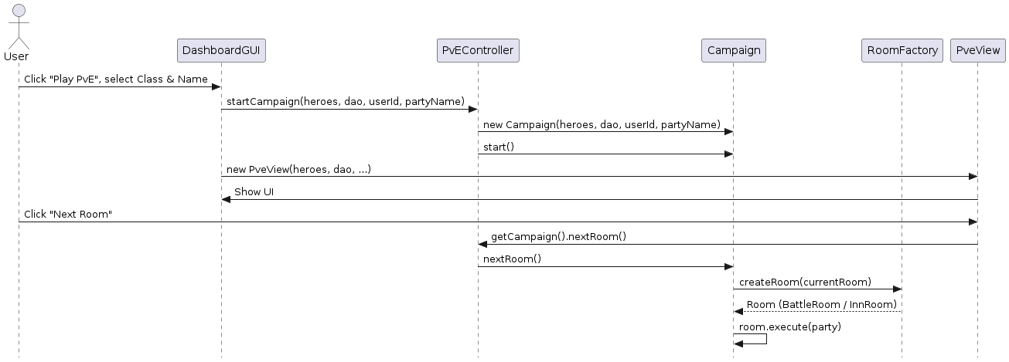

Launching a new PvE campaign initializes the PvEController and Campaign model with the user's chosen starting hero. The Dashboard GUI instantiates the PveView. Progression occurs when the user clicks "Next Room", invoking the Campaign to request a new room from the RoomFactory which executes the room logic.
USE CASE 3: Go through a single battle
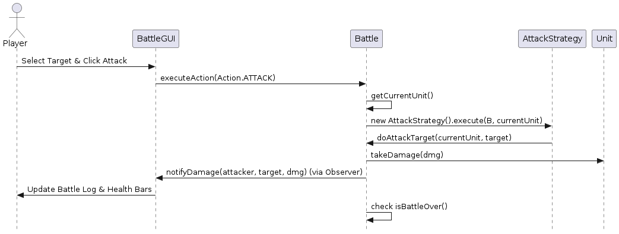
In a battle, the player chooses a target and clicks an action. The BattleGUI delegates this action to the Battle class. The Battle class resolves the action via a Strategy pattern (e.g., AttackStrategy). Damage is applied to the Unit, and the Battle object notifies observers (BattleGUI) to update the visual log and health indicators.

USE CASE 4: The Inn
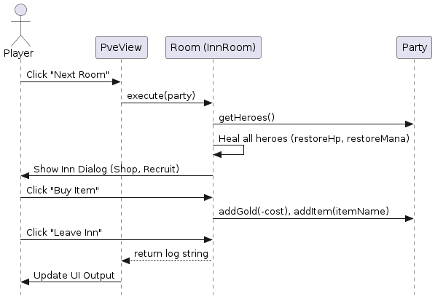
Entering an InnRoom triggers the execute() method via a background worker thread. The Inn immediately restores HP and Mana for all party heroes. A modal dialog presents options to buy items or recruit heroes. Interactions directly modify the Party's gold and inventory states. Leaving the dialog unblocks the thread and returns execution control to the PveView.

USE CASE 5: Exiting and Saving the PvE Campaign
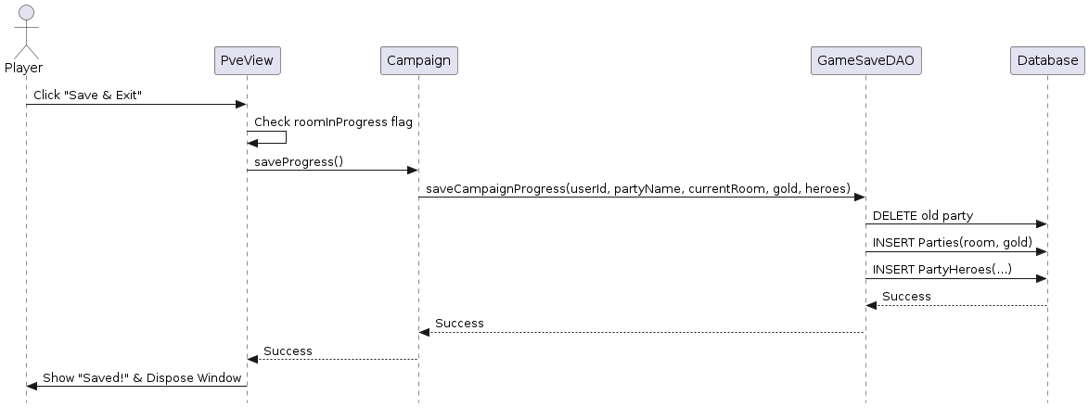
When the player decides to exit the campaign, PveView delegates the save request to the Campaign instance. The Campaign instructs GameSaveDAO to serialize system state, wiping out the former party entries for the given slot and inserting the current states (gold, specific room, deeply-saved heroes) into the relational database.
Use Case 6: Continue an incomplete PvE campaign
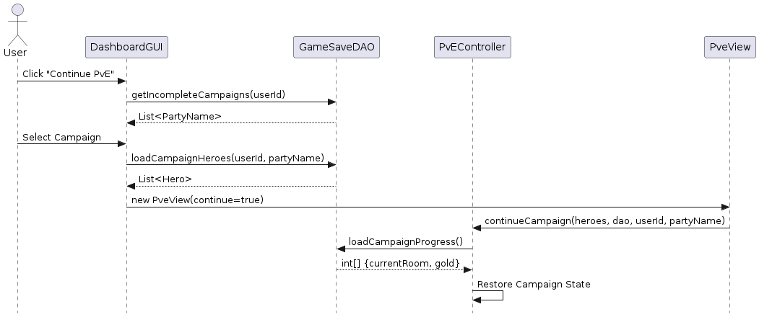
The system queries GameSaveDAO for campaigns yet to reach the final room. The user chooses one, and the Dashboard reconstructs the hero objects via DAOs. It forwards these objects alongside the party name to PveView, which asks PvEController to mount the exact state array variables (gold, room number) obtained from the DB.

Use Case 7: PvP Invitation
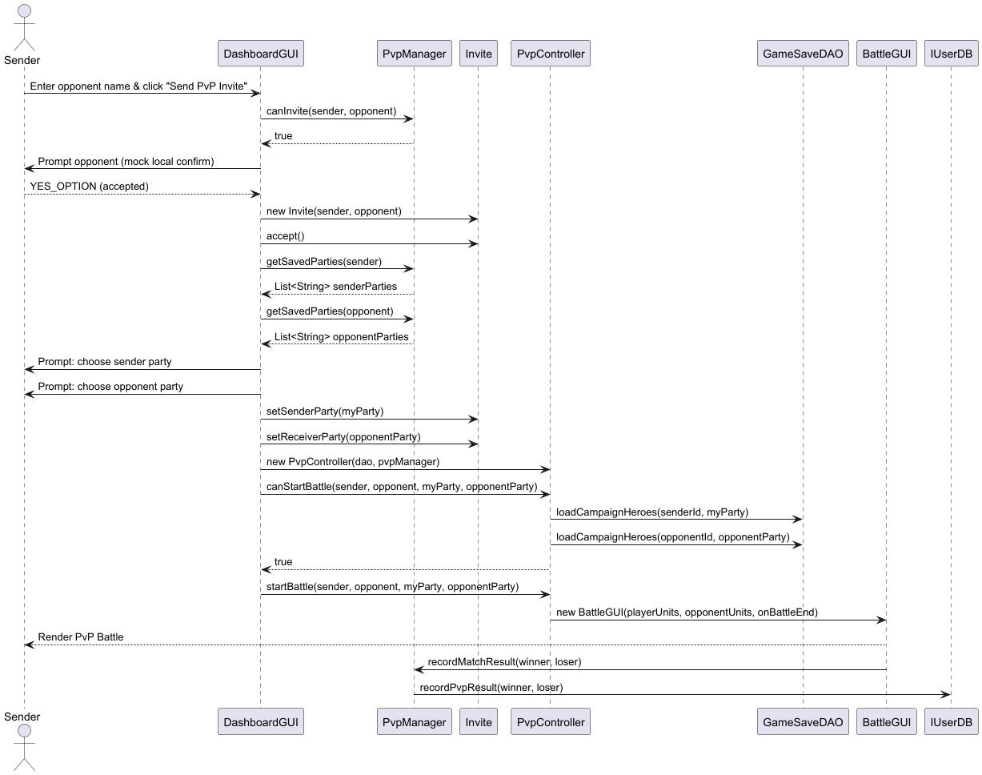
The user enters an opponent username and clicks the button “Send PvP Invite” which then DashboardGUI calls PvpManager.canInvite() to ensure both players meet the PvP requirements. A message pops up to accept the invite which creates the Invite object and makes the players select a saved party. Then, DashboardGUI creates a PvpController and calls canStartBattle() to load the heroes in the players’ parties from GameSaveDAO to check if they meet the criteria. If so, startBattle() is called launching BattleGUI and both players play the battle and the result is recorded.

Architecture

Profile Creation System Modules
Module Name | Description | Exposed Interface Names | Interface Description
M1: UI Module | Handles user interaction such as entering information, button interaction, displays success and error messages, and navigation to the dashboard. | M1:IAuthUI | Methods for user actions involving registration and login
M2: Profile Logic | Contains logic for checking register and login validity. | M2:IAccountService | Methods for account creation and checking login information.
M3: Data Access | Communicates with database to store and get information | M3:IUserDB | Methods for checking username existence, saving user account information and retrieving user data.
M4: Database | Takes care of database connection, executes queries to permanently store data. | M4:IDBConnection | Methods for opening database connection and executing queries.

Profile Creation System Interfaces
Interface Name | Operations | Operation Descriptions
LoginScreen | void register(String username, String password) used by M2  void login(String username, String password) used by M2 | LoginScreen:register(String username, String password) - sends user registration input to account logic.  LoginScreen:login(String username, String password) - sends user login input to account logic.
AccountManager | boolean register(String username, String password) used by M1  boolean login(String username, String password) used by M1 | AccountManager:register(String username, String password) - validates and creates a new user if the username is available  AccountManager:login(String username, String password) - validates user information and returns if login is successful
IUserDB | boolean usernameExists(String username) used by M2  void save(UserProfile user) used by M2  UserProfile findUsername(String username) used by M2 | IUserDB:usernameExists(String username) - checks if a username already exists in the database.  IUserDB:createUser(String username, String password) - stores a new user profile in the database.  IUserDB:findUsername(String username) - retrieves a stored user profile by username.
DatabaseConnector | void openConnection() used by M3  Connection getConnection() used by M3 | DatabaseConnector:openConnection() - establishes a connection to the database.  DatabaseConnector:getConnection() - returns active database connection

DataBase Modules and Interface
Database Modules
Module Name | Description | Exposed Interface Names | Interface Description
PersistenceModule | Handles all interactions with the MySQL database, ensuring that game states, party status, and campaign progress are securely stored and retrieved without exposing SQL logic to the rest of the application. | PM:IGameSave | PM:IGameSave: Provides operations to save the current state of a PvE campaign, including individual hero statistics.

Database Interfaces
Interface Name | Operations | Operation Descriptions
GameSaveDAO | saveCampaignProgress(int userId, String partyName, int currentRoom, int gold, List<Hero> heroes, Map<String, Integer> inventory) used by CampaignManager and PvEModule. | GameSaveDAO:saveCampaignProgress(...): Connects to the database and stores the party's current room, gold, and individual hero stats (HP, Mana, Attack, Defense) using batch SQL statements.
GameSaveDAO | loadCampaignHeroes(int userId, String partyName).  loadCampaignProgress(int userId, String partyName) | PM:IGameSave:fetchSavedCampaign(...): Queries the database to retrieve a user's active campaign, reconstructing the Party and Hero objects to resume the game.

The PersistenceModule acts as the dedicated bridge between the game's core logic and the MySQL database. It is designed to maintain strict boundaries and low coupling; it interacts primarily with the system controllers (such as the PveController and CampaignManager) without exposing any underlying SQL code to them. When a user saves or continues a campaign, the game controllers call the PM:IGameSave interface. The PersistenceModule then executes the necessary database queries, seamlessly translating Java Party and Unit objects into relational data, and vice versa.
PvE System Modules

Module Name | Module Name | Exposed Interface Names | Interface Description
M1: PvE Controller Module | Manages the flow of the campaign, including starting new campaigns, continuing saved campaigns, and retrieving the current campaign. | PvEController | Methods to start campaigns, continue saved campaigns, and get the current campaign.
M2: Campaign Manager | Represents the campaign state: current room, party, score calculation, saving progress, and finishing the campaign. | Campaign | Methods to get/set current room, gold, last inn room, calculate score, save progress, and retrieve party.
M3: Room Factory | Creates rooms (BattleRoom or InnRoom) dynamically based on floor and party level. | RoomFactory | Method to generate a room: createRoom(floor, totalPartyLevel)
M4: Room | Abstract superclass for all room types; defines the contract for executing a room. | Room | Method execute(Party party) that runs the room logic and returns a result string.
M5: Battle Room | Implements battles: generates enemies, launches GUI, calculates victory/defeat rewards and penalties.  . | BattleRoom | Method to execute battle, handle results, update party gold/EXP.
M6: Inn Room | Implements healing, item shop, and hero recruitment; interacts with Swing GUI. | InnRoom | Method to execute room logic, heal heroes, allow item purchase and recruitment.
M7: Party & Hero | Encapsulates the party and heroes, including inventory, gold, health, mana, and experience. | Party / Hero | Methods for adding gold, items, heroes, restoring HP/mana, leveling, and experience gain.
M8: Database / DAO | Saves and loads campaign progress, inventory, and scores. | GameSaveDAO | Methods for saving campaign progress, inventory, and scores; loading state and inventory.

Interface Name | Operations | Operation Description
IPvEControl | startCampaign(List<Hero> heroes)  startCampaign(List<Hero> heroes, GameSaveDAO dao, int userId, String partyName)  continueCampaign(List<Hero> heroes, GameSaveDAO dao, int userId, String partyName)  getCampaign() | - startCampaign(List<Hero> heroes) – Starts a new campaign with the given heroes.  - startCampaign(List<Hero> heroes, GameSaveDAO dao, int userId, String partyName)  – Starts a new campaign with database save integration.  - continueCampaign(List<Hero> heroes, GameSaveDAO dao, int userId, String partyName)  – Loads a saved campaign from the database and continues it.  - getCampaign()  – Returns the currently active campaign instance.
ICampaign | start()  nextRoom()  getParty()  saveProgress() | - start()  – Initializes campaign progression and displays a welcome message.  - nextRoom()  – Advances to the next room, executes its logic, and returns the results as a string.  - getParty()  – Returns the Party object associated with the campaign.  - saveProgress()  – Saves the campaign’s current state, inventory, and gold to the database.
IRoom | execute(Party party)  getFloor() | - execute(Party party)  – Executes room-specific behavior when a party enters. For BattleRoom or InnRoom, this may block until user interaction completes.  - getFloor()  – Returns the floor number of the room.
Party | addHero(Hero hero)  getHeroes()  addGold(int amount)  addItem(String itemName, int quantity) | - addHero(Hero hero)  – Adds a hero to the party.  - getHeroes()  – Returns a list of all heroes in the party.  - addGold(int amount)  – Adds or subtracts gold from the party.  - addItem(String itemName, int quantity)  – Adds the specified quantity of an item to the party’s inventory.

The PvE Controller Module acts as the entry point for PvE mode. It receives a list of heroes and constructs a Party object. It then initializes the Campaign module. The Campaign Module maintains the state of the dungeon, including the current room and the associated party. It provides controlled access to the party through the getParty() method. The Room Interaction Module defines an abstract Room class that declares the enter(Party) method. Concrete implementations such as BattleRoom and InnRoom extend Room and provide specialized behavior when a party enters them. The Party Management Module encapsulates the list of Hero objects and provides controlled operations to modify or retrieve the hero list.

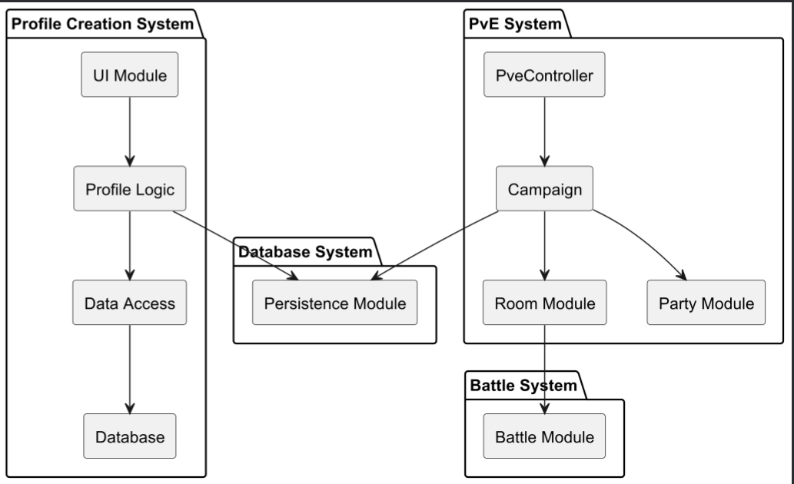

Class Diagrams and Initial Implementation

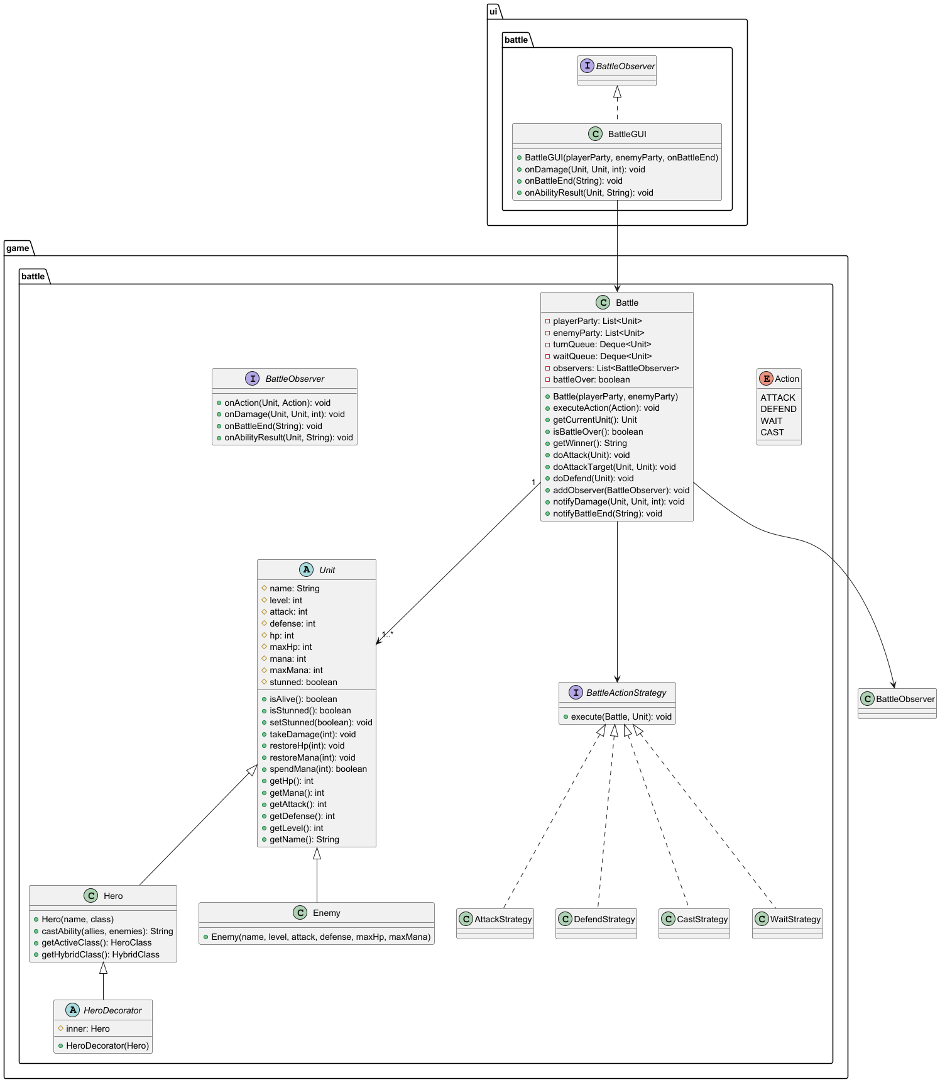

Class name | Attribute/Method name | Description
Unit | Name: String | Name of the unit
Unit | level: int | Current player level
Unit | attack: int | Attack power.
Unit | defense: int | Damage reduction
Unit | hp: int | Current health points
Unit | maxHp: int | Maximum health points of a hero/enemy
Unit | mana: int | Current mana points
Unit | maxMana: int | Maximum mana points
Unit | stunned: boolean | Stun status for whether the unit skips their next turn
Unit | isAlive(): boolean | Returns true if hp > 0
Unit | takeDamage(int): void | Reduces health points by damage
Unit | restoreHp(int amount): void | Increases health points up to max health points
Unit | restoreMana(int amount): void | Increases mana up to maxMana
Battle | enemyParty: List<Unit> | Collection of enemy units
Battle | turnQueue: Queue<Unit> | Queue for turn order
Battle | waitQueue: Queue<Unit> | Queue for units that chose WAIT
Battle | observers:List<BattleObserver> | Observers notified of battle events
Battle | battleOver: boolean | Indicates if battle ended
Battle | executeAction(Action): void | Executes the given action for current unit
Battle | getCurrentUnit(): Unit | Returns the unit whose at turn
Battle | isBattleOver(): boolean | Checks if one side has no more units alive
Battle | getWinner(): String | Returns winning party
Battle | doAttack(Unit): void | Executes an attack on lowest-HP target
Battle | doAttackTarget(Unit, Unit): void | Attack on specific target
Battle | doDefend(Unit): void | Restores 10 HP and 5 Mana
Battle | addObserver(BattleObserver): void | Registers new observer
Battle | notifyDamage(Unit, Unit, Int): void | Tells observers when damage is done
Battle | notifyBattleEnd(String): void | Tells observers when battle ends
Hero | Hero(name, class) | Creates hero with starting class
Hero | castAbility(allies, enemies): String | Performs hero’s class ability
Hero | getActiveClass(): HeroClass | Returns hero’s current active class
Enemy | Enemy(name, level, attack, defense, maxHp, maxMana) | Creates enemy unit
Action | ATTACK, DEFEND, WAIT, CAST | Actions that can be done during a turn
BattleActionStrategy | execute(Battle, Unit): void | Interface defining a single executable action
AttackStrategy | execute(Battle, Unit): void | Attacks lowest-hp enemy or a selected target
DefendStrategy | execute(Battle, Unit): void | Restores hp and mana
CastStrategy | execute(Battle, Unit): void | Performs class’ ability
WaitStrategy | execute(Battle, Unit): void | Passes turn moving it to end of queue
HeroDecorator | Inner:Hero | Wrapped Hero whose stats and state are assigned to
HeroDecorator | HeroDecorator(Hero) | Wraps a hero to allow dynamic stat modification
BattleObserver | onDamage(Unit, Unit, int): void | Called when damage is dealt in battle
BattleObserver | onTurnStart(Unit): void | Called at the start of a unit's turn
BattleObserver | onAction(Unit, Action): void | Called when a unit executes an action
BattleObserver | onBattleEnd(String): void | Called when battle ends
BattleObserver | onAbilityResult(Unit, String): void | Called when ability produces a result
BattleGUI | BattleGUI(playerParty, enemyParty, onBattleEnd) | Constructs and renders battle interface
BattleGUI | onAbilityResult(Unit, String): void | Updates battle log with ability result

Profile Creation and Login Class Diagram
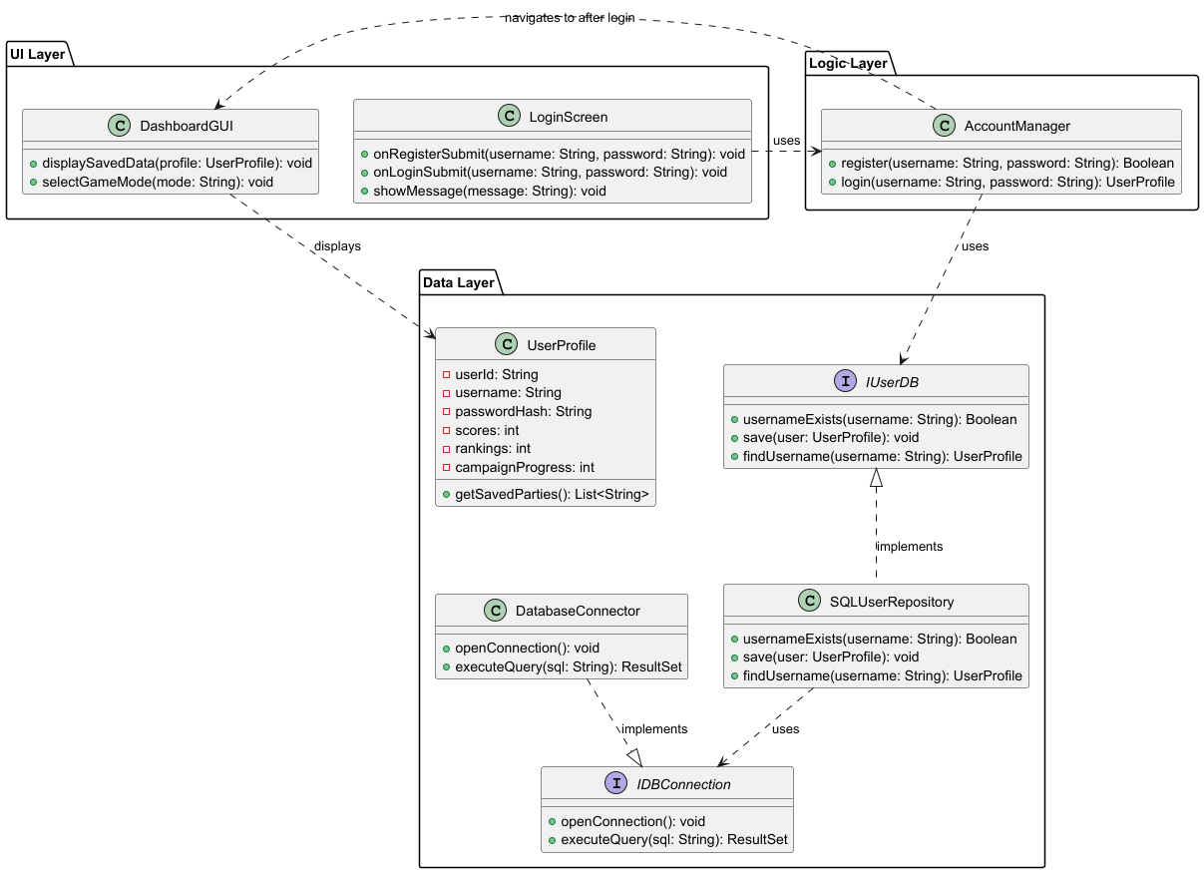

PROFILE CREATION AND LOGIN
Class Name | Attribute/Method Name | Description
LoginScreen | passwordField: JPasswordField | Input field for the password
LoginScreen | accountManager: AccountManager | Handles registration and login logic
LoginScreen | LoginScreen(AccountManager) | Constructs the login window and wires up button listeners
LoginScreen | showMessage(String): void | Displays a popup message dialog for success or failure outcomes
AccountManager | userDB: IUserDB | The IUserDB instance used to communicate with the database
AccountManager | AccountManager(IUserDB) | Constructs the manager with the given IUserDB implementation
AccountManager | register(String, String): boolean | Validates input and creates a new account if the username is not taken
AccountManager | login(String, String): UserProfile | Verifies credentials and returns the UserProfile if successful, null otherwise
AccountManager | getUserDB(): IUserDB | Returns the IUserDB instance for use by other components such as PvpManager
IUserDB | usernameExists(String): boolean | Checks if the given username already exists in the database
IUserDB | createUser(String, String): void | Stores a new user in the database
IUserDB | authenticate(String, String): boolean | Verifies a username and password against stored credentials
IUserDB | findUsername(String): UserProfile | Retrieves a stored UserProfile by username
IUserDB | hasSavedParty(String): boolean | Returns whether the user has at least one saved party
IUserDB | getSavedParties(String): List<String> | Returns all saved party names for the user
IUserDB | recordPvpResult(String, String): void | Records the outcome of a PvP match
IUserDB | findUsername(String): UserProfile | Retrieves a stored UserProfile by username
UserDBProxy | realDB: IUserDB | The real IUserDB implementation being wrapped
UserDBProxy | UserDBProxy(IUserDB) | Wraps a real IUserDB to provide an interception point without modifying the underlying implementation
UserDBProxy | All IUserDB methods | Delegates every call directly to the wrapped realDB instance
JdbcUserDB | dao: GameSaveDAO | The DAO used to execute all SQL operations
JdbcUserDB | JdbcUserDB(GameSaveDAO) | Constructs the DB implementation with a DAO for SQL operations
JdbcUserDB | usernameExists(String): boolean | Checks if a username exists via GameSaveDAO.getUserIdByUsername()
JdbcUserDB | createUser(String, String): void | Creates a new user by delegating to GameSaveDAO.createUser()
JdbcUserDB | authenticate(String, String): boolean | Delegates credential verification to GameSaveDAO.authenticate()
JdbcUserDB | findUsername(String): UserProfile | Builds and returns a UserProfile by loading ID, scores, saved parties, and campaign progress from GameSaveDAO
UserProfile | userId: int | Unique integer ID for the user account
UserProfile | username: String | Username for login and display
UserProfile | scores: int | The user's best campaign score
UserProfile | campaignProgress: int | The furthest room reached across all campaigns
UserProfile | savedParties: List<String> | List of saved party names for the user
UserProfile | getUserId(): int | Returns the user's ID
UserProfile | getUsername(): String | Returns the username
UserProfile | getScores(): int | Returns the best score
UserProfile | setScores(int): void | Sets the best score
UserProfile | getCampaignProgress(): int | Returns the campaign progress room number
UserProfile | setCampaignProgress(int): void | Sets the campaign progress room number
UserProfile | getSavedParties(): List<String> | Returns the list of saved party names
UserProfile | setSavedParties(List<String>): void | Sets the list of saved party names
DatabaseConnector | instance: DatabaseConnector | The single shared instance (Singleton)
DatabaseConnector | getInstance(): DatabaseConnector | Returns the singleton instance, creating it if necessary
DatabaseConnector | getConnection(): Connection | Opens and returns a new JDBC connection to the database

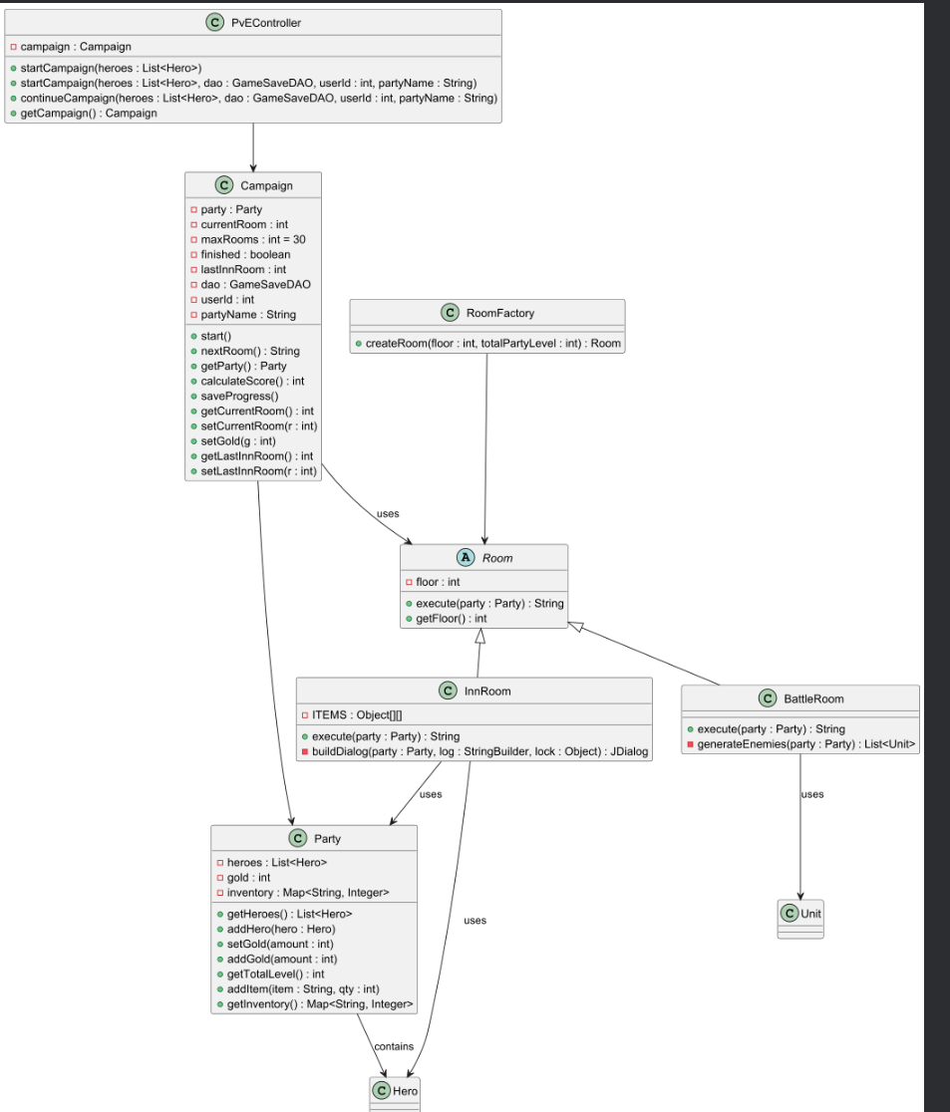

Class Name | Attribute/Method Name | Description
PvEController | campaign : Campaign | Holds the active campaign instance and acts as the entry point for PvE mode.
PvEController | startCampaign(heroes : List<Hero>) | Initializes a new campaign with the given heroes.
PvEController | startCampaign(heroes : List<Hero>, dao : GameSaveDAO, userId : int, partyName : String) | Starts a campaign with saved data integration.
PvEController | continueCampaign(heroes : List<Hero>, dao : GameSaveDAO, userId : int, partyName : String) | Resumes a previously saved campaign, restoring party and inventory.
PvEController | getCampaign() : Campaign | Returns the current active campaign.
Campaign | party : Party | The party associated with this campaign.

Campaign | currentRoom : int | Tracks the current room number.
Campaign | maxRooms : int | Maximum number of rooms in the campaign (30).
Campaign | finished : boolean | Indicates if the campaign is complete.
Campaign | lastInnRoom : int | Tracks the last inn visited for hero recovery/recruiting.
Campaign | dao : GameSaveDAO | Database access object for saving/loading campaign data.
Campaign | userId : int | Identifier for the player in the database.
Campaign | partyName : String | Name of the party.
Campaign | start() | Begins the campaign, displaying a welcome message.
Campaign | nextRoom() : String | Progresses to the next room, executing room-specific behavior.
Campaign | getParty() : Party | Returns the campaign’s party.
Campaign | calculateScore() : int | Computes the final score based on heroes, inventory, and gold.
Campaign | saveProgress() | Saves the current campaign state to the database.
Campaign | getCurrentRoom() : int | Returns the current room number.
Campaign | setCurrentRoom(r : int) | Updates the current room safely within bounds.
Campaign | setGold(g : int) | Updates party gold.
Campaign | getLastInnRoom() : int | Returns last inn room number.
Campaign | setLastInnRoom(r : int) | Updates last inn room safely.
Room (abstract) | floor : int | Floor number of the room.
Room (abstract) | execute(party : Party) : String | Abstract method; defines room specific behavior when a party enters.
Room (abstract) | getFloor() : int | Returns the floor number.
BattleRoom (extends Room) | execute(party : Party) : String | Generates enemies, runs the battle via BattleGUI, computes rewards or penalties.
BattleRoom (extends Room) | generateEnemies(party : Party) : List<Unit> | Creates a list of enemy units based on party strength.
InnRoom (extends Room) | ITEMS : Object[][] | Static array of items available for purchase or use.
InnRoom (extends Room) | execute(party : Party) : String | Heals all heroes, allows item purchases, recruits heroes, and waits for player interaction.
InnRoom (extends Room) | buildDialog(party : Party, log : StringBuilder, lock : Object) : JDialog | Constructs the interactive inn GUI.
RoomFactory | createRoom(floor : int, totalPartyLevel : int) : Room | Dynamically returns either a BattleRoom or InnRoom based on party level and probability.

Party | heroes : List<Hero> | List of heroes in the party.
Party | Gold :int | Amount of gold the party has
Party | inventory : Map<String, Integer> | Tracks items and quantities.
Party | getHeroes() : List<Hero> | Returns the list of heroes.
Party | addHero(hero : Hero) | Adds a hero to the party.
Party | setGold(amount : int) | Sets party gold.
Party | addGold(amount : int) | Modifies party gold.
Party | getTotalLevel() : int | Returns total combined hero levels.
Party | addItem(item : String, qty : int) | Adds an item to the inventory.
Party | getInventory() : Map<String, Integer> | Returns inventory map.

Database UML Diagram
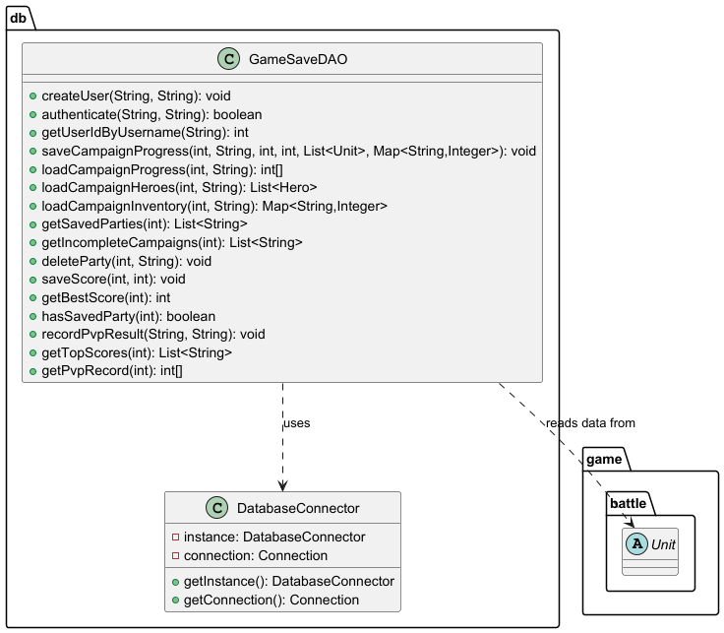

Class Name | Attribute/Method Name | Description
DatabaseConnector | URL: String | The JDBC connection string to the local MySQL database
DatabaseConnector | USER: String | The database username credential
DatabaseConnector | PASS: String | The database password credential
DatabaseConnector | instance: DatabaseConnector | The single shared instance (Singleton pattern)
DatabaseConnector | getInstance(): DatabaseConnector | Returns the singleton instance, creating it if necessary
DatabaseConnector | getConnection(): Connection | Opens and returns a new JDBC connection to the database
GameSaveDAO | createUser(String, String): void | Inserts a new user with a hashed password into the Users table
GameSaveDAO | authenticate(String, String): boolean | Verifies a username and hashed password against the database
GameSaveDAO | getUserIdByUsername(String): int | Returns the user's ID, or -1 if not found
GameSaveDAO | saveCampaignProgress(int, String, int, int, List<Unit>, Map<String,Integer>): void | Deletes the existing party entry and inserts the current room, gold, heroes, and inventory into the database
GameSaveDAO | loadCampaignProgress(int, String): int[] | Returns the current room and gold for a saved party as an int array
GameSaveDAO | loadCampaignHeroes(int, String): List<Hero> | Reconstructs all Hero objects for a saved party from the database
GameSaveDAO | loadCampaignInventory(int, String): Map<String,Integer> | Returns the saved inventory map for a party
GameSaveDAO | getSavedParties(int): List<String> | Returns all party names saved for a given user ID
GameSaveDAO | getIncompleteCampaigns(int): List<String> | Returns party names where current_room < 30, ordered by most recent
GameSaveDAO | deleteParty(int, String): void | Cascades deletion of a party's inventory, heroes, and party record
GameSaveDAO | saveScore(int, int): void | Inserts a campaign completion score into the Scores table
GameSaveDAO | getBestScore(int): int | Returns the user's highest recorded score
GameSaveDAO | hasSavedParty(int): boolean | Returns whether the user has at least one saved party
GameSaveDAO | recordPvpResult(String, String): void | Records a PvP match result and increments win/loss counts for both players
GameSaveDAO | getTopScores(int): List<String> | Returns the top N username-score pairs across all users for the Hall of Fame
GameSaveDAO | getPvpRecord(int): int[] | Returns the win and loss count for a user as an int array

PvP Class Diagram

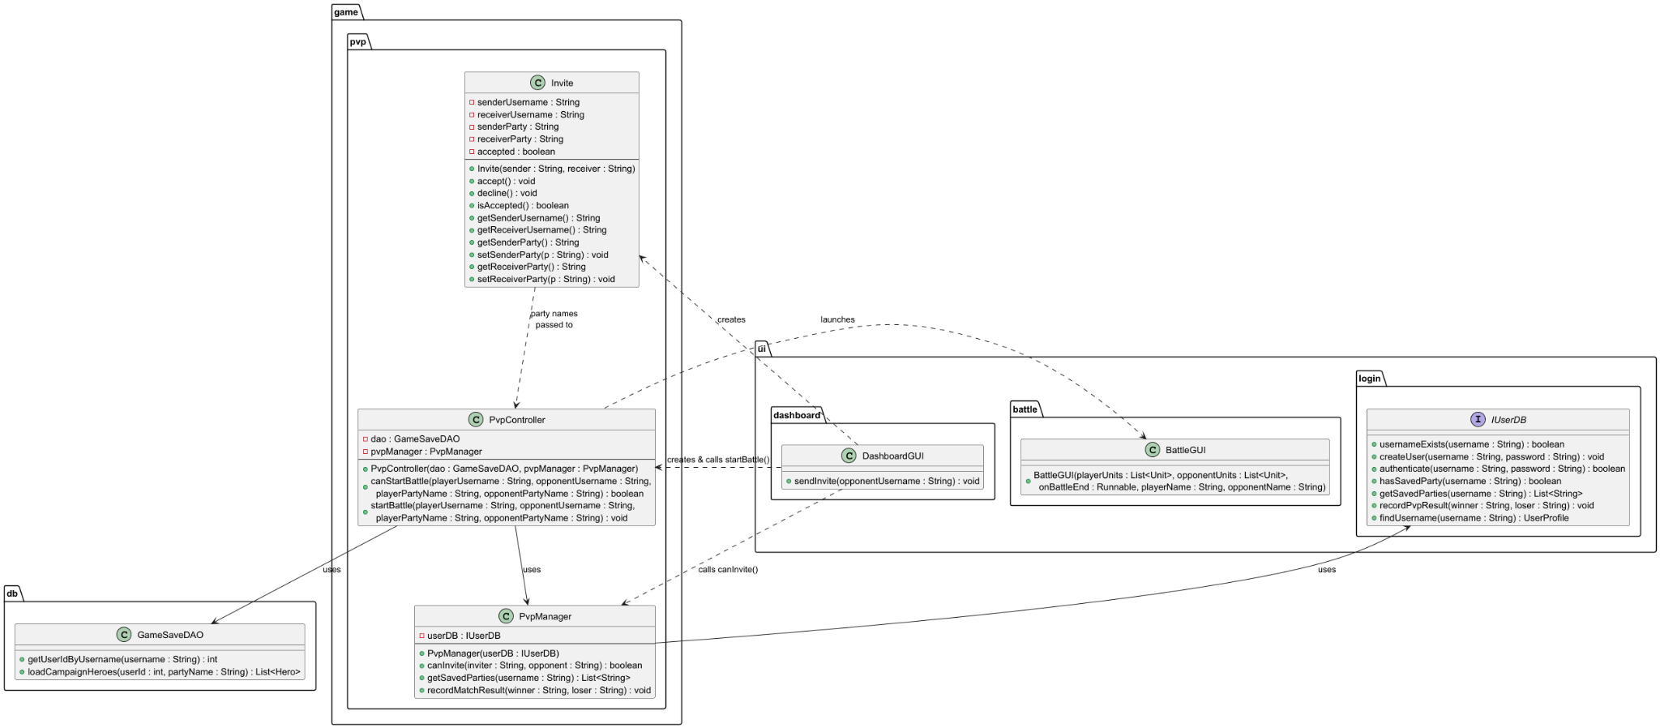

Class Name | Attribute/Method Name | Description
PvpManager | userDB: IUserDB | The user database used to validate invites and retrieve saved parties
PvpManager | PvpManager(IUserDB) | Constructs the manager with an IUserDB implementation
PvpManager | canInvite(String sender, String opponent): boolean | Returns true if both players exist, are different users, and each has at least one saved party
PvpManager | getSavedParties(String username): List<String> | Returns the list of saved party names for the given username
PvpManager | recordMatchResult(String winner, String loser): void | Records the PvP match outcome by delegating to IUserDB.recordPvpResult()
PvpController | dao: GameSaveDAO | DAO used to load hero data and record match results
PvpController | pvpManager: PvpManager | Manager used for invite validation and result recording
PvpController | PvpController(GameSaveDAO, PvpManager) | Constructs the controller with a DAO and PvP manager
PvpController | canStartBattle(String playerUsername, String opponentUsername, String playerPartyName, String opponentPartyName): boolean | Loads both parties from the database and returns true if both have at least one hero
PvpController | startBattle(String playerUsername, String opponentUsername, String playerPartyName, String opponentPartyName): void | Loads both parties, creates a Battle instance, launches BattleGUI, and records the result on completion
Invite | senderUsername: String | Username of the player who sent the invite
Invite | receiverUsername: String | Username of the invited player
Invite | senderParty: String | Party name selected by the sender
Invite | receiverParty: String | Party name selected by the receiver
Invite | accepted: boolean | Whether the invite has been accepted
Invite | Invite(String sender, String receiver) | Creates an invite between two players
Invite | accept(): void | Marks the invite as accepted
Invite | decline(): void | Marks the invite as declined
Invite | isAccepted(): boolean | Returns whether the invite was accepted
Invite | getSenderUsername(): String | Returns the sender's username
Invite | getReceiverUsername(): String | Returns the receiver's username
Invite | getSenderParty(): String | Returns the sender's chosen party name
Invite | setSenderParty(String): void | Sets the sender's chosen party name
Invite | getReceiverParty(): String | Returns the receiver's chosen party name
Invite | setReceiverParty(String): void | Sets the receiver's chosen party name

Design Patterns
The PvE module employs several well-known design patterns to achieve modularity, flexibility, and maintainability. The Factory Pattern is used in RoomFactory to dynamically create BattleRoom or InnRoom instances based on party level and probability, decoupling object creation from the controller. The PvEController serves as a Facade, providing a single entry point for starting or continuing campaigns and hiding the complexity of Campaign, Party, and database interactions. The abstract Room class uses a Template/Strategy Pattern, defining the execute() method while allowing subclasses to implement specific room behaviors. Both BattleRoom and InnRoom use a Callback/Observer Pattern with Swing GUI interactions and wait/notify to handle asynchronous user input without blocking the controller logic. The Campaign class interacts with GameSaveDAO through the DAO Pattern, separating persistence from business logic. Finally, the Party class aggregates multiple Hero objects in a Composite-like structure, allowing operations on the party as a whole while managing individual heroes. Together, these patterns ensure high cohesion, low coupling, and a scalable architecture for the PvE system.

Singleton Pattern
The Singleton pattern is implemented in the DatabaseConnector class. This class maintains a single shared instance through a private static variable and provides global access via a getInstance() method. By restricting instantiation, the system ensures that only one database connection manager exists at runtime. This is particularly important for managing JDBC connections efficiently, as it avoids unnecessary duplication of connection objects and ensures consistent interaction with the database across all modules. The use of the Singleton pattern simplifies resource management and prevents potential conflicts arising from multiple concurrent connection instances.

Factory Method Pattern
The Factory Method pattern is used within the RoomFactory class. This class encapsulates the logic required to create different types of rooms, such as BattleRoom and InnRoom, based on parameters like the current floor or party level. Instead of the Campaign class directly instantiating room objects, it delegates this responsibility to the factory. This design centralizes object creation and allows the system to easily extend or modify room generation logic without altering the core campaign flow. As a result, the code remains flexible and adheres to the Open/Closed Principle.

Strategy Pattern
The Strategy pattern is applied in the battle system through the BattleActionStrategy interface and its concrete implementations, such as AttackStrategy, DefendStrategy, CastStrategy, and WaitStrategy. Each strategy encapsulates a specific action that can be performed during a battle. The Battle class dynamically selects and executes these strategies based on the player’s chosen action. This eliminates the need for large conditional statements and allows new battle actions to be added without modifying existing logic. The pattern promotes clean separation of behavior and enhances extensibility within the combat system.

Observer Pattern
The Observer pattern is utilized in the interaction between the Battle class and the BattleGUI. The Battle class maintains a list of observers through the BattleObserver interface, and the BattleGUI registers itself as a listener. Whenever a significant event occurs during a battle, such as damage being dealt or an action being executed, the Battle class notifies all registered observers. This allows the GUI to update in real time without being tightly coupled to the battle logic. The Observer pattern effectively separates the game’s core logic from its presentation layer, improving modularity and maintainability.

Decorator Pattern
The Decorator pattern is implemented through an abstract class named HeroDecorator. It works by wrapping an existing Hero object and passing all statistics and state calls through to Hero. This allows for temporary bonuses to be applied to a hero during runtime without altering the base Hero class. Any additional effects can be implemented by creating a HeroDecorator subclass which keeps the hero structure untouched.

Proxy Pattern
The Proxy pattern is used in the UserDBProxy class, which implements the IUserDB interface and acts as an intermediary between the application and the JdbcUserDB class. Instead of directly interacting with the database implementation, components such as the AccountManager communicate with the proxy. The proxy can control access, perform validation, or add additional behavior such as logging before delegating requests to the real database object. This abstraction enhances security, reduces direct dependency on the database layer, and provides flexibility for future modifications without affecting the rest of the system.

Activities Plan, Product Backlog, and Sprint Backlog
In this section provide the following:
The product backlog includes implementation of advanced combat mechanics, additional room types, hero abilities, item systems and enhanced database features, expansion. Deliverable 1 focuses on foundational systems: profile creation, core battle mechanics, PvE progression, and database integration. Deliverables 2 and 3 will expand functionality, refactor code to include additional design patterns, and improve system robustness.
Gantt Diagram
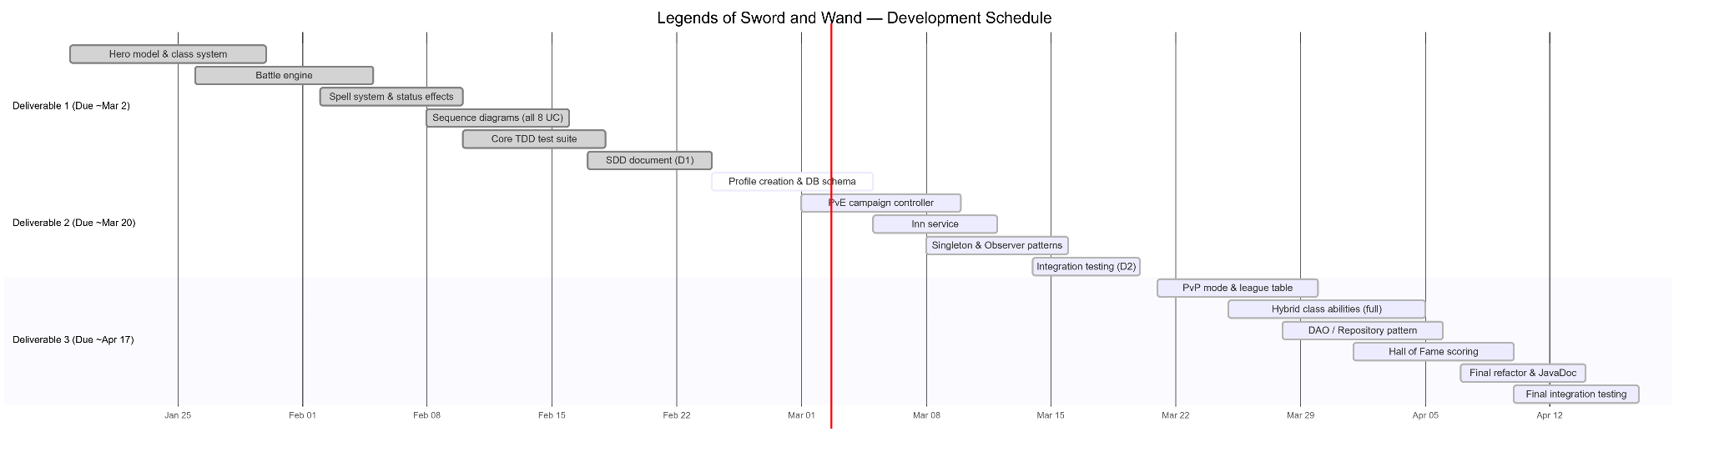
Product Backlog

ID | Item | Deliverable
PB-01 | Hero model + class system | D1 (done)
PB-02 | Battle engine (turn-based) | D1 (done)
PB-03 | Spell / ability system | D1 (done)
PB-04 | Status effects (stun, shield) | D1 (done)
PB-05 | Sequence diagrams (all 8 UC) | D1 (done)
PB-06 | Core test suite (27 tests) | D1 (done)
PB-07 | Profile creation & persistence | D1 (done)
PB-08 | PvE campaign controller | D1(done)
PB-10 | Database integration (MySQL) | D1 (done)
PB-09 | Inn service | D2
PB-11 | Singleton pattern (LeagueService, CampaignController) | D2
PB-12 | Observer pattern (HP/level-up events) | D2
PB-13 | PvP mode + league table | D3
PB-14 | Hybrid class ability upgrades (full set) | D3
PB-15 | Repository / DAO pattern | D3
PB-16 | Hall of Fame scoring | D3
PB-17 | Full integration testing | D3
PB-18 | Final refactoring & JavaDoc | D3

Group Meeting Logs
Minutes | Attendance | Topics | Decisions | Tasks
45 | Everyone | Foundation  Role Picks  Project plan/  Organization | Decided to use microservice architecture with Spring Boot services | Kevin: Profile, PvP, Data  Tobi: PvE, Battle
35 | Everyone | Progress Check  Group Work session  Q&A  Research | Confirmed API endpoints for profile service and battle service | Kevin: Implement profile service and database connection. Tobi: Continue battle engine
15 | Everyone | Diagram creation  Architecture review | Agreed on sequence diagrams for main use cases | Kevin: Profile, data and PvP diagrams.  Tobi: PvE and battle diagrams
40 | Everyone | Docker and CI/CD | Containerize each service and use Docker Compose | Kevin + Tobi: Implement Dockerfiles and database service
30 | Everyone | Review document | Edited and Revised document and services | Kevin + Tobi: Double check document and services

Test Driven Development (TDD)
Test ID | PC-TC01
Category | Registration (New user registers)
Requirements Coverage | PC-Successful-Register
Initial Condition | System has been initiated and runs, available database connection and username does not exist.
Procedure | - User enters username  - User enters password  - User clicks register
Expected Outcome | The user's new profile is created and saved in the database then a success message shows up notifying the user.
Notes | User should provide a valid input  Password should be stored as a hash

Test ID | PC-TC02
Category | Registration (Username exists)
Requirements Coverage | PC-Unsuccessful-Register
Initial Condition | The system has been initiated and runs, available database connection and username does exist.
Procedure | - User enters username  - User enters password  - User clicks register
Expected Outcome | The user receives an error message and registration doesn’t continue
Notes

Test ID | PC-TC03
Category | Login (Valid Authentication)
Requirements Coverage | PC-Successful-Login
Initial Condition | The system has been initiated and runs, username is stored and exist in database
Procedure | - User enters correct username  - User enters correct password  - User clicks login
Expected Outcome | Login is successful and user is transferred to dashboard GUI
Notes

Test ID | PC-TC04
Category | Login (Failed Authentication)
Requirements Coverage | PC-Unuccessful-Login
Initial Condition | The system has been initiated and runs, username is stored and exist in database
Procedure | - User enters correct username  - User enters incorrect password  - User clicks login
Expected Outcome | Login is unsuccessful and user is notified of incorrect password input
Notes | Dashboard doesn't appear.

Test ID | DB-TC-01
Category | Database Insertion / Party Status
Requirements Coverage | UC5-Save-Campaign-Progress
Initial Condition | The system is connected to the MySQL database, and User ID 1 exists in the Users table.
Procedure | 1. The system creates a list containing two Hero objects (e.g., "Arthur" and "Merlin") with specific HP and Mana values.  2. The system calls saveCampaignProgress(1, "The Round Table", 12, 500, heroes).
Expected Outcome | A new row is added to the Parties table with room 12 and 500 gold. Two new rows are added to the Heroes table, linked to the new party's ID, with exact matching stats.
Notes | Verifies the core requirement of storing party status and campaign progress correctly.

Test ID | DB-TC-02
Category | Database Integrity / Error Handling
Requirements Coverage | UC5-Save-Campaign-Progress
Initial Condition | The system is connected to the MySQL database. User ID 999 does not exist in the Users table.
Procedure | 1. The system attempts to save a party by calling saveCampaignProgress(999, "Lost Souls", 5, 100, heroes).
Expected Outcome | The MySQL database rejects the insertion due to a Foreign Key constraint failure. The Java catch block triggers, prints an error message, and no data is written to the Parties or Heroes tables.
Notes | Ensures that orphan records cannot be created without a valid user profile.

Test ID | DB-TC-03
Category | Database Management / Cascading Deletes
Requirements Coverage | UC1-Profile-Management
Initial Condition | User ID 2 exists and has an active saved campaign in the Parties table, along with associated heroes in the Heroes table.
Procedure | 1. The system executes a SQL command to delete User ID 2 from the Users table (e.g., simulating account deletion).  2. The system queries the Parties and Heroes tables for records linked to User ID 2.
Expected Outcome | The queries return 0 results. The ON DELETE CASCADE rule from the SQL schema successfully wiped the user's party and hero data automatically.
Notes | Validates the database schema design and ensures the database doesn't fill up with dead data from deleted accounts.

Test ID | BS-TC-01
Category | Battle System (Action)
Requirements Coverage | UC3-Attack-Damages-HP
Initial Condition | The system is running and there is at least one attacker and one enemy. Target’s HP is more than 0.
Procedure | - Start battle with 1 hero against 1 enemy  - Record target HP before attack  - Call handleAttack(attacker)
Expected Outcome | Enemy’s HP decreases, but not below 0.
Notes

Test ID | PVE-TC-02
Category | PvE System
Requirements Coverage | UC2-Start-Campaign
Initial Condition | The system is running and PveController exists. The hero list is available.
Procedure | - Create PveController  - Call startCampaign()  - Call getCampaign and then getParty()
Expected Outcome | Campaign is created, the party now exists with the selected heroes.
Notes

Test ID | PVE-TC-02
Category | PvE System
Requirements Coverage | UC6-Continue-Campaign-Progress
Initial Condition | The database contains a saved campaign for the user.
Procedure | - User chooses Continue Campaign in dashboard  - Controller calls DAO to obtain the saved campaign data
Expected Outcome | The user’s party and heroes are rebuilt and the UI brings the user to the user’s view before they exited.
Notes

Test ID | PVP-TC01
Category | PvP Invitation
Requirements Coverage | PC-Send-Invite
Initial Condition | System has been initiated and runs, available database connection, both users exist
Procedure | - User A enters User B username  - User A sends the invite  - System checks if User B exists and invite requirements are met
Expected Outcome | A PvP invite is created and stored, User B gets the invite notification
Notes | Users should have valid profiles

Test ID | PVP-TC01
Category | PvP Invitation
Requirements Coverage | PC-Accept-Invite
Initial Condition | System has been initiated and runs, available database connection, a valid PvP invite exists
Procedure | - User B receives PvP invite  - User B accepts invite  - System verifies if invite is valid
Expected Outcome | PvP status is updated to accepted and both users are sent to a new battle session
Notes

Use of AI

